JavaScript Objects, Prototypes, and Classes

Zawartość

JavaScript Object 2

Object properties 7

Prototypes and Interfaces 9

Classes 12

Build in classes in JS 14

# JavaScript Object

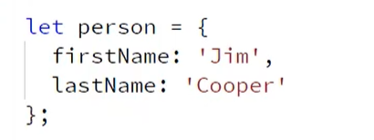

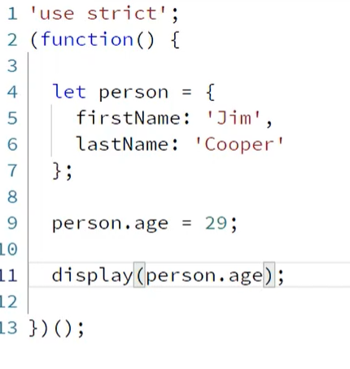

In JS object can be extends dynamically.

P. S. in js always create code in this way to make all object in local scope and clean up memory after use them.

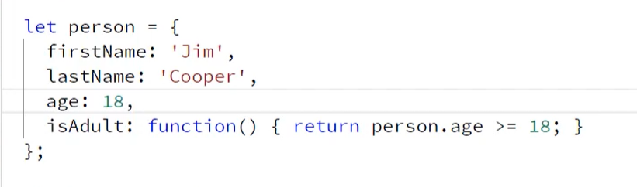

Object can have function as property.

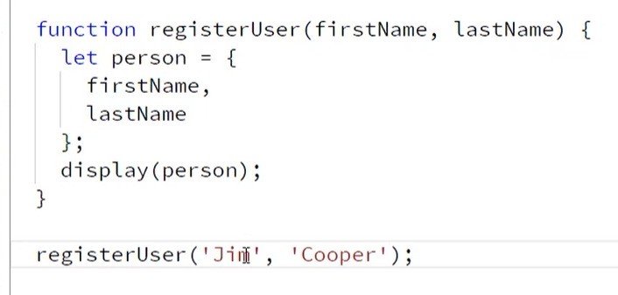

Object can be created in function.

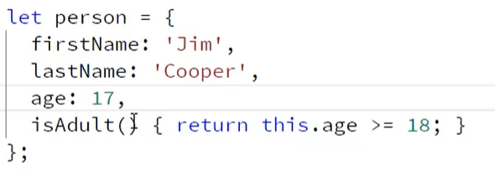

Method can be shorted without function keyword

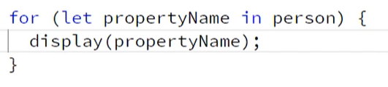

Object properties can be display in for in loop.

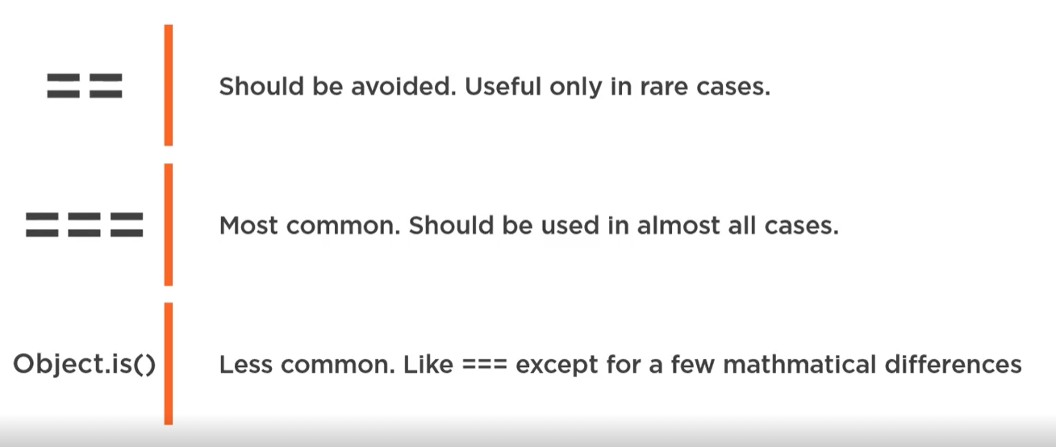

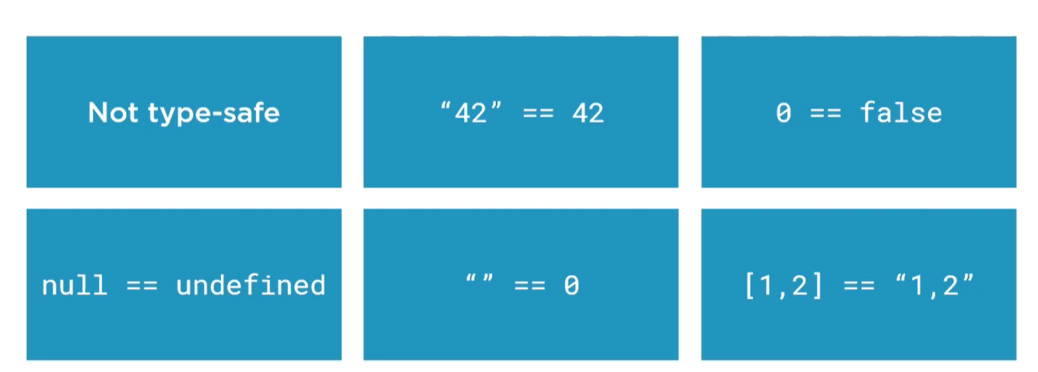

Don’t use.

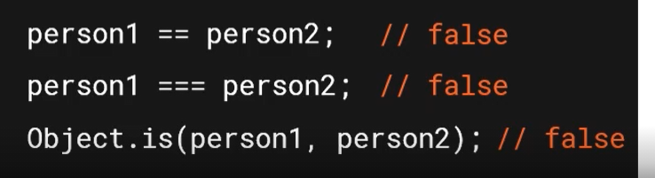

These compare operation return false because this is a reference type.

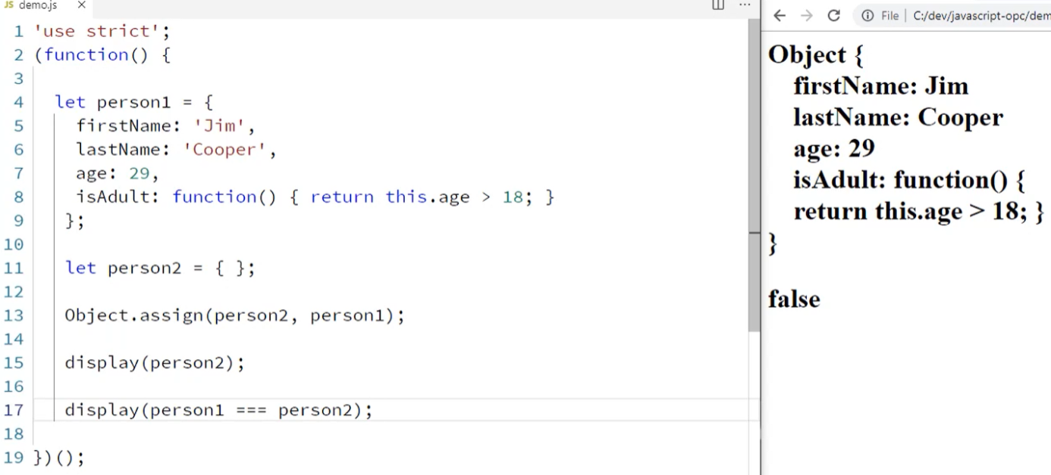

Assign method create new object with parameter from second one.

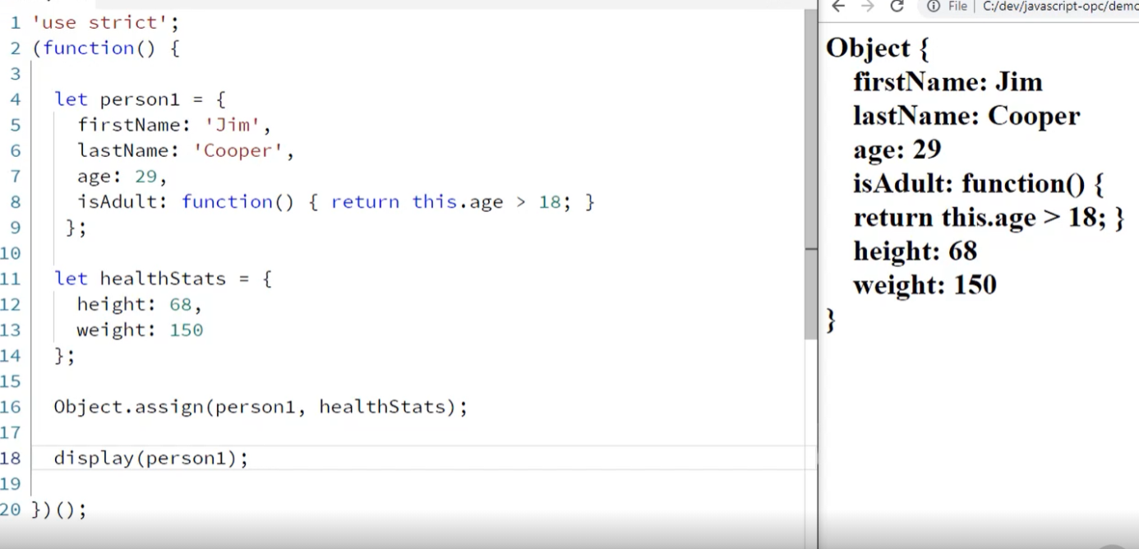

With this method can be assign more properties.

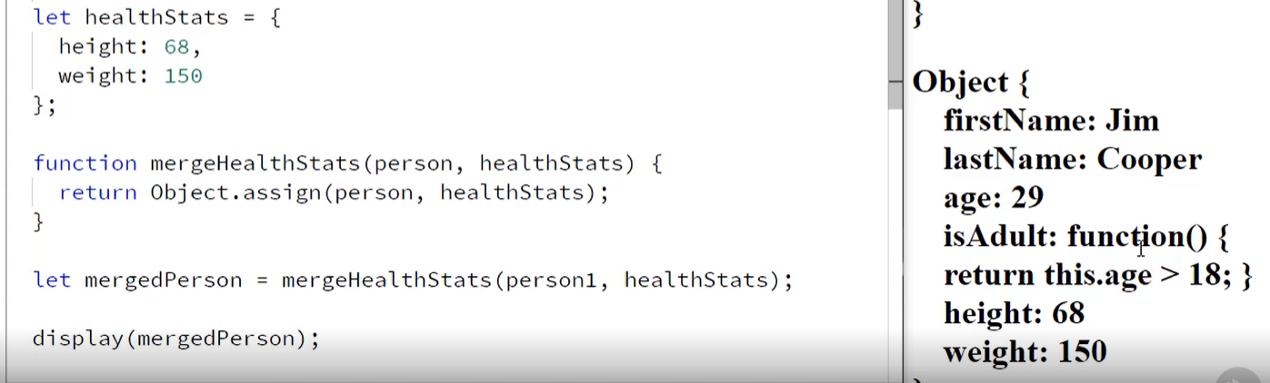

If we pass object and object with new properties it will be mutated.

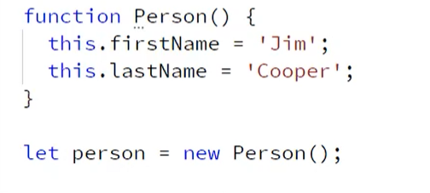

In function Person(). It is create a new object with two properties. It works like constructor but we don’t have a normal property only there are added dynamically.

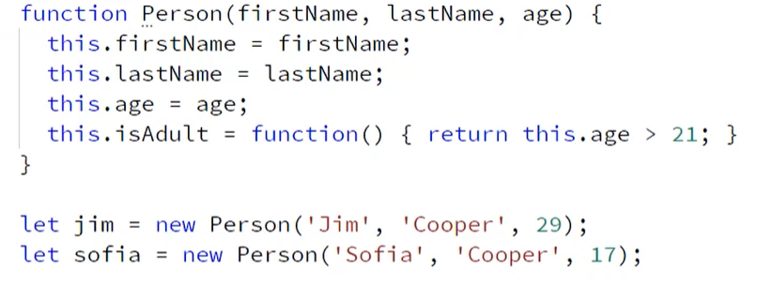

Almost like constructor ☺.

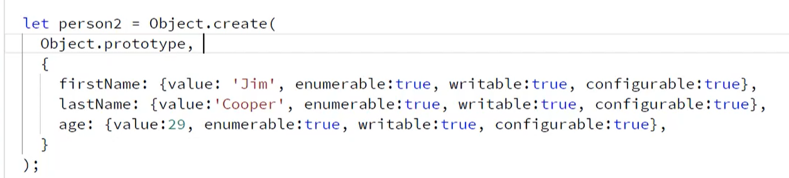

Object can be create by Object property with object prototype and some properties.

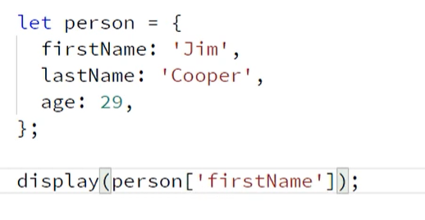

Bracket notation to get prop.

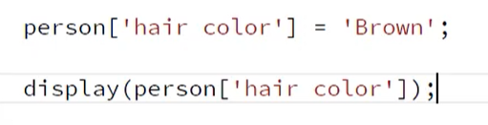

Prop can be added in this way

# Object properties



Object class use properties to make an operation.

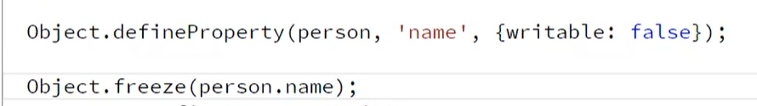

In this way prop can be created or freeze to don’t make it final.

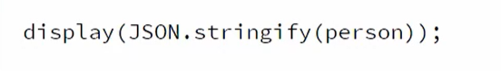

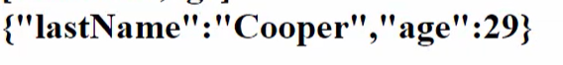

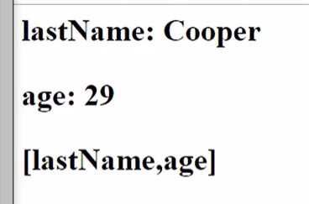

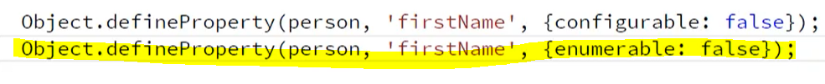

If configuration is set on false. We can change configurable and enumerable. 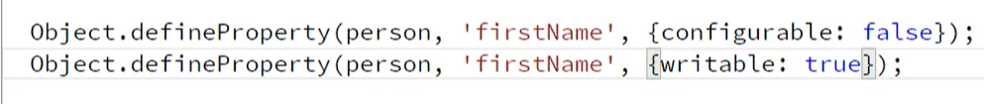

But we can change a writable ☺

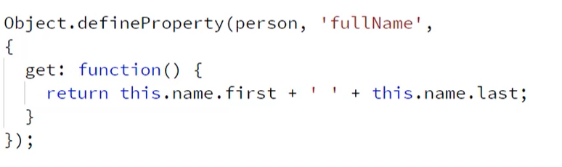

With prototypes we can add a function.

# Prototypes and Interfaces

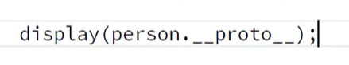

Each object in js is a prototype. Or inherit all features from Object prototype.In different programming languages there are class Object and each object is a child of this class. In JS is prototype of object proto.

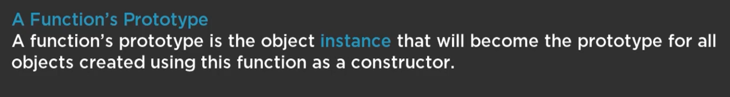



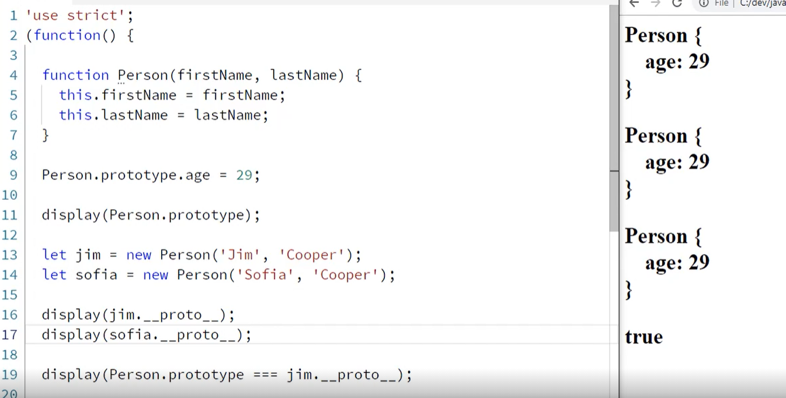

Each object created by Person(args) is based on a Person prototype. So if someone modified a prototype like in our example in 9th line then all object which take after this proto features will be modified.



We can change proto from child object too.

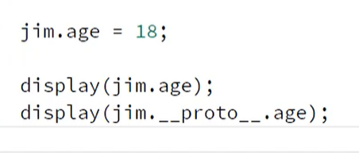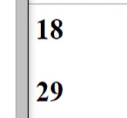

Another great example of js magic. Each object has own properties, but it has too a proto properties like in example above. When we don’t add jim.age = 18 this objet has only proto value.

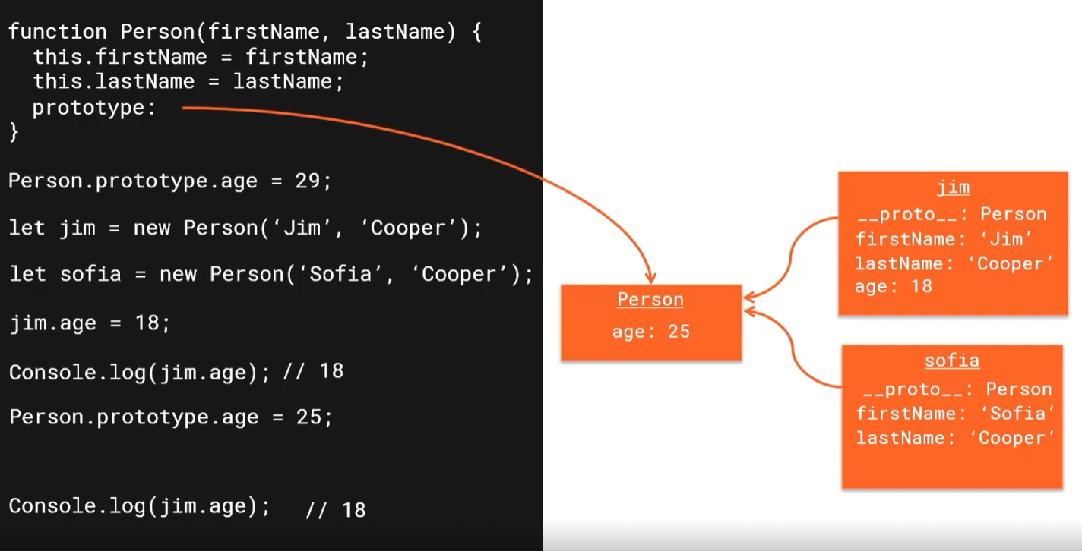

Each object has own props and proto. If there is no property then interpreter will be lokking for a property in proto.

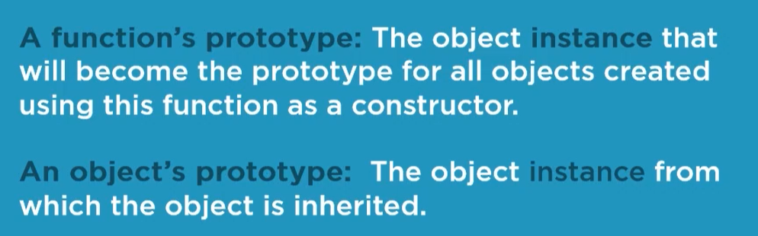

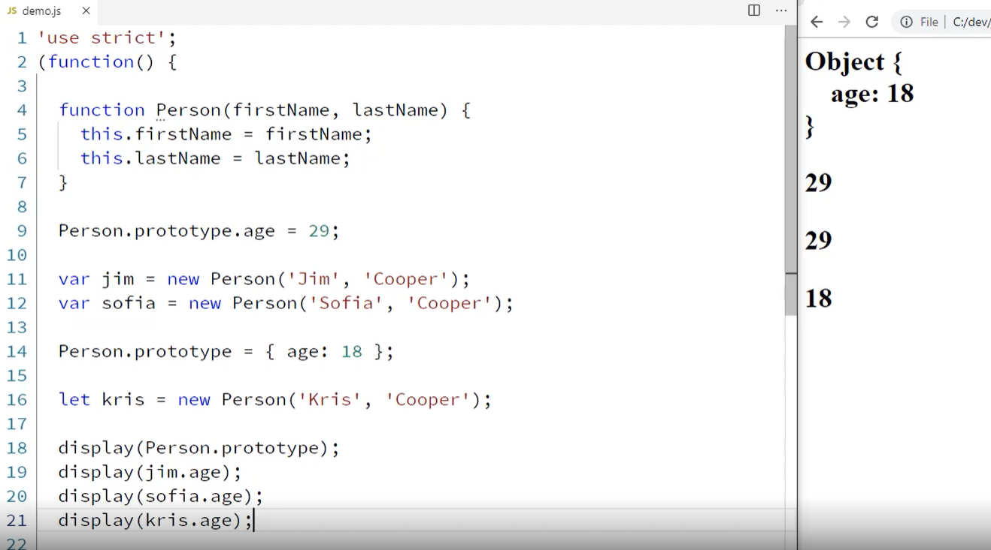

In this example kris has different name then rest object because prototype has been updated before kris has been initialize.

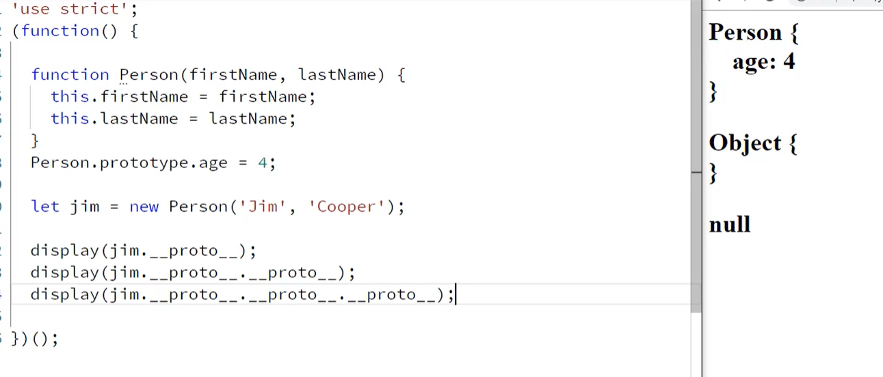

Each object in js inherit from proto except an Object. This is a top of the mountain of if you prefer last cell in prototype chain. This chain will be extend by next class and inheritance.

# Classes

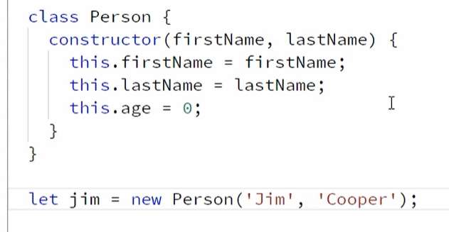

Now it looks great, like a normal class.

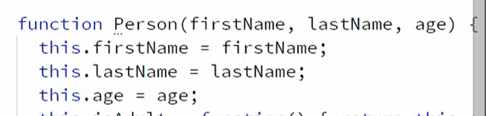

It the same but with class and constructor is more readable.

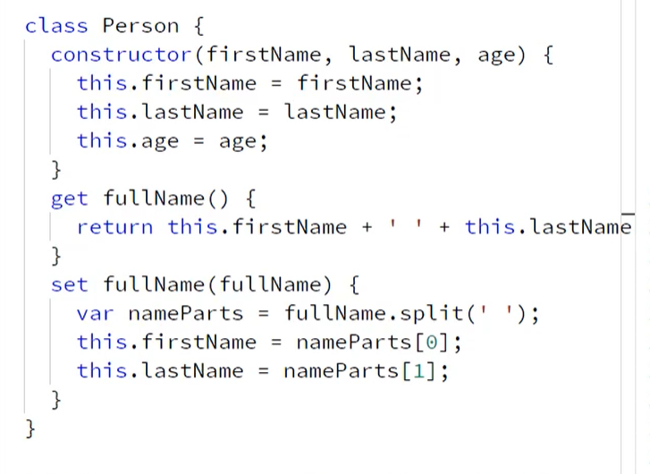

Get and set is use to… create getter and setter. They both keywords can be use to each property or to new one.

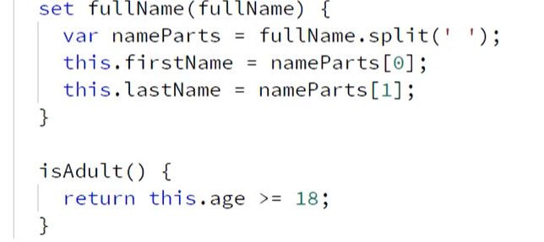

Adding function is super easy too.

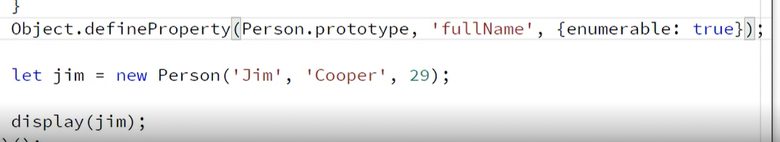

Too display with get and set property required is define property in Proto and change enumerable in true.

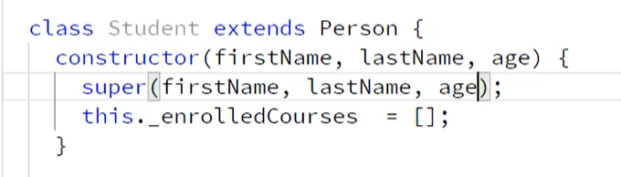

To inherit properties required is extend key word and super(). It works like in normal Java. Extends is used to extends ☺ inherit after a ParentClass. Super is a constructor on ParentClass and it will be invoke when normal constructor will.

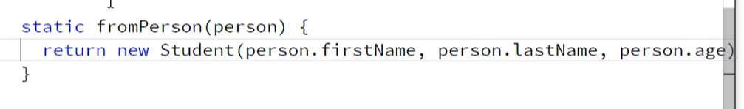

To make a static function just use this keyword before function name.

# Build in classes in JS

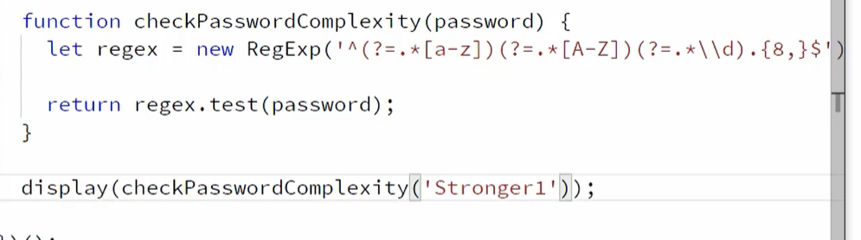

RegExp means regular expression. This property is use to validate password, if password has required marks it will be true if not its false.